A-Review of Simulink for Single phase Rectifier

**Salam Waley Shneen*1 , Roshen Tariq Ahmedhamdi2 , Moafaq K.S. Al-Ghezi3**

Energy and Renewable Energies Technology Center, University of Technology, Iraq

[salam.w.shneen@uotechnology.edu.iq](mailto:salam.w.shneen@uotechnology.edu.iq)1, [roshen.t.ahmedhamdi@uotechnology.edu.iq](mailto:roshen.t.ahmedhamdi@uotechnology.edu.iq)2, [moafaq.k.shiea@uotechnology.edu.iq](mailto:moafaq.k.shiea@uotechnology.edu.iq)3

***Abstract***

*The current review aims to firstly simulate the work of the electronic transformer on the one hand and secondly, analyze and design different types on the other hand in addition to the third objective by evaluating and improving the system components. To work on achieving the goals of this review and to cover the largest number of possible cases that enable researchers to identify the most important joints of the topic to develop a study in reviewing the work of the electronic transformer. The number of electronic keys has been approved in terms of representing the number of phases on one side and the type of wave on the other hand such as one half phase Full wave or wave, as well as single-phase, which will be detailed later. The type of electronic keys has also been adopted in terms of the representation of electronic keys in the form of a diode, a transistor or a thyristor.*

***Keywords****: Simulink, single-phase Rectifier, HWR and FWR.*

***Copyright*** © ***2019 Universitas Ahmad Dahlan. All rights reserved.***

**1. Introduction**

Electronic transformer, it had include DC_DC, DC_AC, AC_AC & AC_DC [1-3]. The type of AC_DC called rectifier [4-6]. The rectifier used when the load is DC and the source was AC [7-9]. There are many applications in industrial like battery chargers, HVDC and Elevator …etc. [10-13].

There are many types of rectifier with familiar switch. The familiar switch model include single-phase uncontrolled, single-phase controlled, three-phase uncontrolled and three-phase controlled. These switches required device type nonlinear for examples thyristors like (SCR, GOT&TRIAC), transistors like (IGBT) and diodes. The switch type uncontrolled like diode had no control like low power and high power. The number of switches in rectifier system was one or four at using single phase but it was three or six at using three phase [14-16].

Single phase include HWR and FWR. The HWR had source and one switch at using single phase or three switches at three phase. The FWR had source and four switches at using single phase or six switches at three phase. Uncontrolled rectifier, there are using diodes that had no control. Controlled rectifier, there are using different switches like MOSFET, IGBT, TRIAC ….etc. [17-19].

In this review had simulated many types for rectifier, uncontrolled rectifier HWR & FWR and controlled rectifier HWR & FWR. In addition, this review had simulated the different load(R, R_L & R_C).

**2. Simulation and Mathematic Model**

Electronic transformer(ET), an ET is used to convert an alternating current or voltage into a constant current or voltage, meaning that its input is an alternating current or voltage and the output of a constant current or voltage[20-22].

The electronic transformer is composed of electronic switches, which are non-linear devices such as diode, transistor and thyristor. Switches for Rectifier, It had classified to controller like power transistor or thyristor (IGBT, SCR, TRIAC and GTO), uncontrolled like diode, bidirectional (TRIAC or two SCR) and unidirectional like (diode, SCR) [23-25].

PETS Uncontrolled, in this type, by using diode (switches) with 1 phase, one diode in HWR and four diodes in FWR. Also, with 3 phases, three diode in HWR and six diodes in FWR. The evaluation, analysis, and improvement of the work of electronic devices depends on their components, their output current, current, voltage, power, and other factors such as:

1st ; Root Mean Square Values include output, voltage($V_{rms}$), current($I_{rms}$).

$$V_{rms}={\left\{\frac{1}{T}\int_{0}^{T}{V^{2}\left(t\right)dt}\right\}}^{0.5} (1)$$

$$I_{rms}={\left\{\frac{1}{T}\int_{0}^{T}{I^{2}\left(t\right)dt}\right\}}^{0.5} (2)$$

2nd ; Average Values include voltage($V_{avg}$), Current($I_{avg}$).

$$V_{avg}=\frac{1}{T}\int_{0}^{T}{V\left(t\right)dt (3)}$$

$$I_{avg}=\frac{1}{T}\int_{0}^{T}{I\left(t\right)dt (2)}$$

3rd ; INPUT Source Power(Pac), OUTPUT Power(Pdc).

$$P_{ac}=V_{rms}.I_{rms} (5)$$

$$P_{dc}=V_{avg}.I_{avg} (6)$$

4th ; Efficiency (η).

$$η=\frac{P_{ac}}{P_{dc} }=\frac{V_{rms}.I_{rms}}{V_{avg}.I_{avg} } (7)$$

5th ; factors include: ripple factor(RF), form factor(FF), harmonic factor(HF), crest factor(CF), and power factor(PF).

$$RF=\frac{V_{ac}}{V_{dc}} (8)$$

$$FF=\frac{V_{rms}}{V_{avg}} (9)$$

$$HF={\left[{\left({I_{s1}}/{I_{s}}\right)}^{2}-1\right]}^{0.5} (10)$$

$$CF=\frac{I_{s(peak)}}{I_{s}} (11)$$

$$PF={I_{s1}}/{I_{s}}cos∅ (12)$$

Simulation, in this part the review include first single-phase HWR system with different load at R, R_L & R_C. Second single-phase FWR system with different load at R, R_L & R_C. The simulation results for Single-phase HWR system in and the table (2) simulation results for Single-phase FWR system in table (3).

Single-phase HWR&FWR, in this section include two parts uncontrolled single-phase HWR&FWR and controlled single-phase HWR&FWR[26].

**2.1. Uncontrolled single-phase HWR & FWR**

Uncontrolled single-phase HWR & FWR, In this part, include two states (HWR&FWR):

**2.1.1. Uncontrolled single-phase HWR**

The uncontrolled single-phase HWR by using diode. The table (1) include the characteristic of the parameter system and the table (2) include the simulation results for uncontrolled single-phase HWR. The figure (1) shows the simulation model for Single phase HWR. The figures (2-4) shows the simulation results for Single phase HWR.

Table 1. Characteristic of the parameter for

Single-phase HWR system.

|  |  |
| --- | --- |
| Parameters | Values |
| Supply Voltage(V) | 314 |
| Supply Frequency(Hz) | 50 |
| R(Ω) | 25 |
| L(mH)  C(µF) | 200  100 |



a) Simulation model for Single-phase HWR system at Load (R)



b) Simulation model for Single-phase HWR system at Load (R_L)



c) Simulation model for Single-phase HWR system at Load (R_C)

Figure 1. Simulation model for Single-phase HWR system at Load a) R b) R_L c) R_C

Table2. Simulation results for Single-phase HWR system.

|  |  |
| --- | --- |
| Load types Vavg(V) Iavg(A) Vrms(V) | Irms(A) |
| R(Ω)= 25 99.54 3.982 156.5 | 6.259 |
| R(Ω)& L(mH)=200 71.08 1.653 118.4 | 2.674 |
| R(Ω) & C(µF)=100 284.2 0.1651 284.6 | 0.4522 |

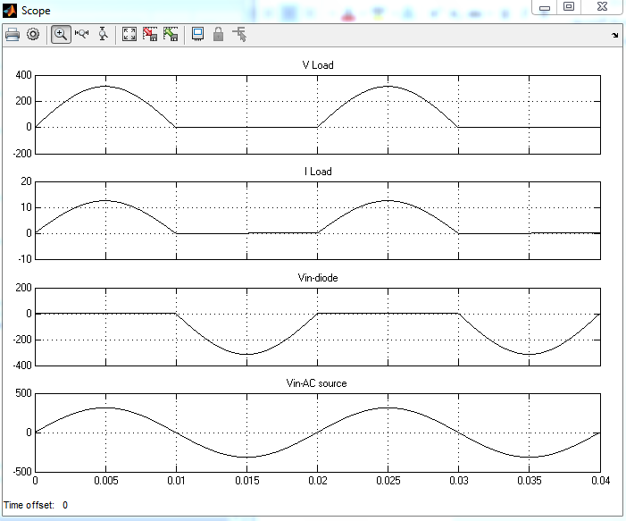

Figure2.simulation results for Single phase HWR Load (R)

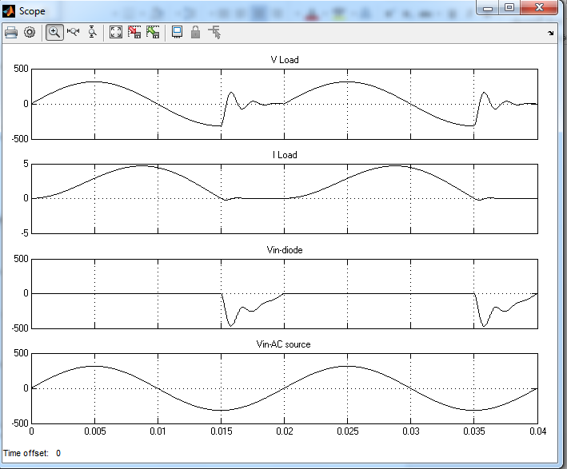

Figure3.simulation results for Single phase HWR Load (R_L)

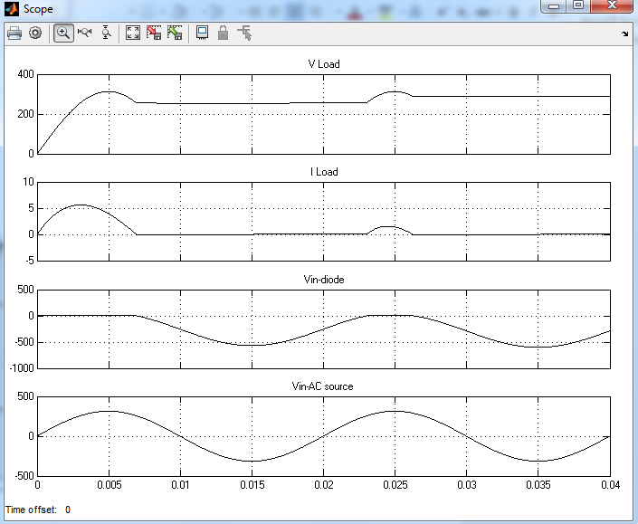

Figure4.simulation results for Single phase HWR Load (R_C)

**2.1.2. Uncontrolled single-phase FWR**

The uncontrolled single-phase FWR by using diode. The table (3) include the characteristic of the parameter system. The table (4) include the simulation results for uncontrolled single-phase FWR. The figure (5) as show the simulation model for Single phase FWR. The figures (6&7) as show the simulation results for Single phase FWR.

Table 3. Characteristic of the parameter for

Single-phase FWR system.

|  |  |
| --- | --- |
| Parameters | Values |
| Supply Voltage(V) | 314 |
| Supply Frequency(Hz) | 50 |
| R(Ω) | 31.4 |
| L(mH) | 30 |



a) Simulation model for Single-phase FWR system at Load (R)



b) Simulation model for Single-phase FWR system at Load (R_L)

Figure5. Simulation model for Single-phase FWR system at Load a) R b) R_L

Table4. Simulation results for Single-phase FWR system at Load (R-L).

|  |  |
| --- | --- |
| Load types Vavg(V) Iavg(A) Vrms(V) | Irms(A) |
| R(Ω)= 31.4 198.3 6.315 220.6 | 7.025 |
| R(Ω)& L(mH)=200 198.3 6.315 220.6 | 6.831 |

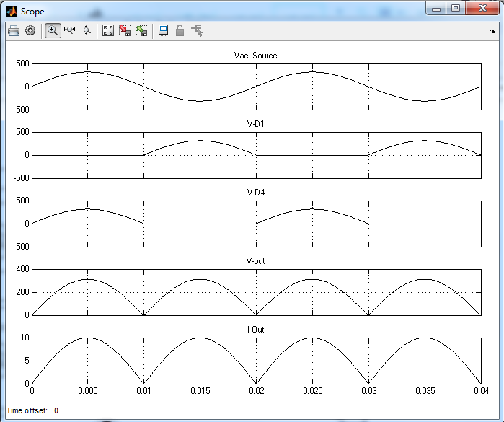

Figure6.simulation results for Single phase FWR Load (R)

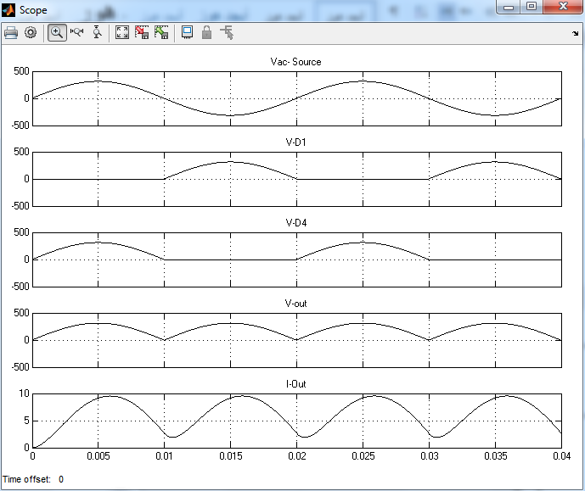

Figure7.simulation results for Single phase FWR at Load (R_L )

**2.2. Controlled single-phase HWR& FWR**

Controlled single-phase HWR& FWR In this part, include two states (HWR&FWR):

**2.2.1. Controlled single-phase HWR**

The controlled single-phase HWR by using diode. The table (5) include the characteristic of the parameter system and the table (6) include the simulation results for controlled single-phase HWR. The figure (8) shows the simulation model for Single phase HWR. The figures (9&10) shows the simulation results for Single phase HWR.

Table 5. Characteristic of the parameter for

Single-phase HWR system.

|  |  |
| --- | --- |
| Parameters | Values |
| Supply Voltage(V) | 314 |
| Supply Frequency(Hz) | 50 |
| R(Ω) | 54 |
| C(µF) | 235 |



a) Simulation model for Single-phase HWR system at Load (R)



b) Simulation model for Single-phase HWR system at Load (R_C)

Figure8. Simulation model for Single-phase HWR system at Load a) R b) R_L c) R_C

Table6. Simulation results for Single-phase HWR system at Load (R-C).

|  |  |
| --- | --- |
| Load types Vavg(V) Iavg(A) Vrms(V) | Irms(A) |
| R(Ω)= 54 71.08 1.653 118.4 | 2.674 |
| R(Ω)=30& C(µF)=235 168.7 0.5498 170.9 | 1.127 |

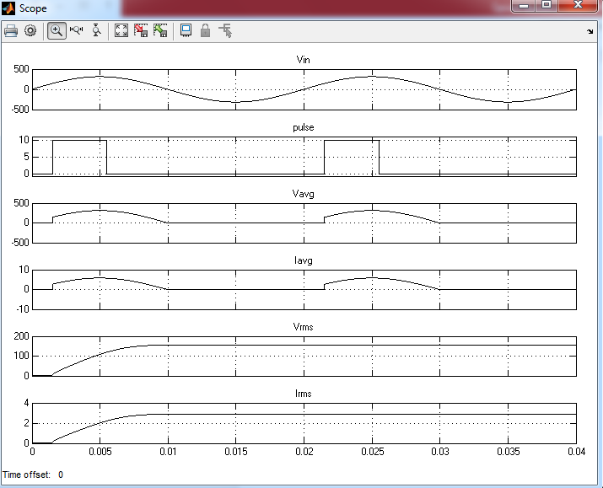

Figure9.simulation results for Single phase HWR Load (R)

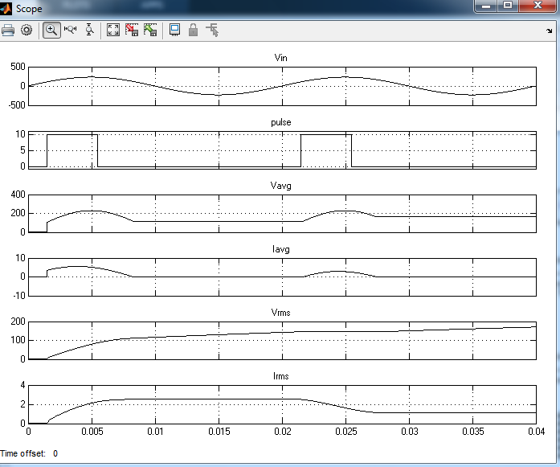

Figure10.simulation results for Single phase HWR Load (R_C)

**2.2.2. Controlled single-phase FWR**

The controlled single-phase FWR by using diode. The table (7) include the characteristic of the parameter system. The table (8) include the simulation results for uncontrolled single-phase FWR. The figure (11) as show the simulation model for Single phase FWR. The figures (12&13) as show the simulation results for Single phase FWR. The table (9) include the simulation calcalation for Characteristic values for HWR and FWR.

Table7.Characteristic of the parameter for

Single-phase FWR system.

|  |  |
| --- | --- |
| Parameters | Values |
| Supply Voltage(V) | 314 |
| Supply Frequency(Hz) | 50 |
| R(Ω) | 31.4 |
| L(mH) | 30 |

Table8. Simulation results for Single-phase FWR system at Load (R-L).

|  |  |
| --- | --- |
| Load types Vavg(V) Iavg(A) Vrms(V) | Irms(A) |
| R(Ω)= 31.4 198.3 6.315 220.6 | 7.025 |
| R(Ω)=30& L(mH)=30 198.3 6.315 220.6 | 6.831 |

Table 9. Characteristic values for HWR and FWR

|  |  |  |
| --- | --- | --- |
| Characteristic type | Characteristic values for HWR | Characteristic values for FWR |
| Pdc(watt) | 396.328 | 1252.32 |
| Pac(watt) | 979.69 | 1549.82 |
| η% | 10.45 | 80.80 |
| FF | 1.57 | 1.11 |
| RF | 1.21 | 0.481 |



a) Simulation model for Single-phase FWR system at Load (R)



b) Simulation model for Single-phase FWR system at Load (R_L)

Figure11. Simulation model for Single-phase FWR system at Load a) R b) R_L



Figure12.simulation results for Single phase FWR Load (R)



Figure13.simulation results for Single phase FWR at Load (R_L )

Simulation Results, the Simulation Results had four stats in this review include uncontrolled HWR, uncontrolled FWR, controlled HWR and controlled FWR. The simulation result for uncontrolled HWR as show figures (2-4).The simulation result for uncontrolled HWR at Load was (R) as show figures (2), The simulation result for uncontrolled HWR at Load was (R-L) as show figures (3), The simulation result for uncontrolled HWR at Load was (R-C) as show figures (4). The simulation result for uncontrolled FWR as show figures (6&7). The simulation result for uncontrolled FWR at Load was (R) as show figures (6), and the simulation result for uncontrolled FWR at Load was (R-L) as show figures (7). The simulation result for controlled HWR as show figures (9&10).The simulation result for controlled HWR at Load was (R) as show figures (9), and the simulation result for controlled HWR at Load was (R-C) as show figures (10). The simulation result for controlled FWR as show figures (12&13). The simulation result for controlled FWR at Load was (R) as show figures (12), and the simulation result for controlled FWR at Load was (R-L) as show figures (13.

**3. Conclusion**

Writing any reviwe under any title that requires comprehensive knowledge of the proposed system, parts that represents. The idea that is to be express in addition to setting. A goal for it to be working on a realization and can be resorted to a set of goals and to achieve. It work is done with appropriate steps starting from the appropriate. Theoretical study to work on developing a model appropriate to achieve Objectives for the proposed idea. In this review, include single-phase HWR system with different load at R, R_L & R_C. Second single-phase FWR system with different load at R, R_L & R_C.

**References**

1. Habetler, Thomas G. "A space vector-based rectifier regulator for AC/DC/AC converters." IEEE Transactions on Power Electronics 8.1 (1993): 30-36.‏
2. Safonov, Valery, and Mikhail Dziuba. "Voltage regulation and phase quantity increase of two high-power 12-phase rectifiers." Int J Pow Elec & Dri Syst ISSN 2088.8694 (2019): 1455.‏
3. Shneen, Salam Waley, Chengxiong Mao, and Dan Wang. "Advanced optimal PSO, Fuzzy and PI controller with PMSM and WTGS at 5Hz side of generation and 50Hz Side of Grid." International Journal of Power Electronics and Drive Systems 7.1 (2016): 173.‏
4. Singh, Bhim, et al. "A review of single-phase improved power quality AC-DC converters." IEEE Transactions on industrial electronics 50.5 (2003): 962-981.‏
5. Shneen, Salam Waley. "Advanced optimal for power-electronic systems for the grid integration of energy sources." Indonesian Journal of Electrical Engineering and Computer Science 1.3 (2016): 543-555.‏
6. Taybi, A., et al. "A New Configuration of a High Output Voltage 2.45 GHz Rectifier for Wireless Power Transmission Applications." Telkomnika 16.5 (2018): 1939-1946.‏
7. Khan, Mohammed Masum Siraj, et al. "Input switched single phase buck and buck-boost AC-DC converter with improved power quality." 2012 7th International Conference on Electrical and Computer Engineering. IEEE, 2012.‏
8. Shneen, Salam Waley. "Advanced Optimal for Three Phase Rectifier in Power-Electronic Systems." Indonesian Journal of Electrical Engineering and Computer Science 11.3 (2018): 821-830.‏
9. Taybi, A., et al. "A new design of high output voltage rectifier for rectenna system at 2.45 GHz." Indonesian Journal of Electrical Engineering and Computer Science 13.1 (2019): 226-234.‏
10. Miyauchi, Ryoichi, Koichi Tanno, and Hiroki Tamura. "New active diode with bulk regulation transistors and its application to integrated voltage rectifier circuit." International Journal of Electrical & Computer Engineering (2088-8708) 9.2 (2019).‏
11. Shneen, Salam Waley, et al. "Application of LFAC... for electrical power transmission system: a comparative simulation study." TELKOMNIKA 17.2 (2019): 1055-1064.‏
12. Ghosh, Rajesh, and G. Narayanan. "A simple analog controller for single-phase half-bridge rectifier." IEEE transactions on power electronics 22.1 (2007): 186-198.‏
13. Kumar, K., et al. "A Novel Six-Switch Power Converter for Single-Phase Wind Energy System Applications." Advances in Smart Grid and Renewable Energy. Springer, Singapore, 2018. 267-275.‏
14. Shneen, Salam Waley. "BBO Tuned FLC for Three Phase Rectifier." International Research Journal of Advanced Engineering and Science 3.1 (2018): 262-267.‏
15. Grinó, Robert, Enric Fossas, and Domingo Biel. "Sliding mode control of a full-bridge unity power factor rectifier." Nonlinear and adaptive control. Springer, Berlin, Heidelberg, 2003. 139-148.‏
16. Asli, Astrie Nurasyeila Fifie, and Yan Chiew Wong. "3.3 V DC output at-16dBm sensitivity and 77% PCE rectifier for RF energy harvesting." International Journal of Power Electronics and Drive Systems 10.3 (2019): 1398.‏
17. Ahmed, Nabil A. "Modeling and simulation of ac–dc buck-boost converter fed dc motor with uniform PWM technique." Electric power systems research 73.3 (2005): 363-372.‏
18. Shneen, Jaafar Ali Kadhum Salam Waley, and Mahdi Ali Abdul Hussein. "Utilization of DC motor-AC generator system to convert the solar direct current into 220v alternating current."‏
19. Mohamed, Nour, Tedjini Hamza, and Gasbaoui Brahim. "Novel DTC induction machine drive improvement using controlled rectifier for DC voltage tuning." Int J Pow Elec & Dri Syst 10.3 (2019): 1223-1228.‏
20. Sasikala, Rajagopal, and R. Seyezhai. "Review of AC-DC power electronic converter topologies for power factor correction." International Journal of Power Electronics and Drive Systems 10.3 (2019): 1510.‏
21. Baharom, Rahimi, and Mohammad Nawawi Seroji. "Dynamic analysis of the high-power factor three-phase AC to DC converter using current injection hybrid resonant Technique." International Journal of Power Electronics and Drive Systems 10.1 (2019): 538.‏
22. Shneen, Salam Waley. "Advanced Optimal for PV system coupled with PMSM." Indonesian Journal of Electrical Engineering and Computer Science 1.3 (2016): 556-565.‏
23. Asli, Astrie Nurasyeila Fifie, and Yan Chiew Wong. "3.3 V DC output at-16dBm sensitivity and 77% PCE rectifier for RF energy harvesting." International Journal of Power Electronics and Drive Systems 10.3 (2019): 1398.‏
24. Sarowar, Golam, and Md Ashraful Hoque. "High Efficiency Single Phase Switched Capacitor AC to DC Step Down Converter." Procedia-Social and Behavioral Sciences 195 (2015): 2527-2536.‏
25. Bouafassa, Amar, Lazhar Rahmani, and Saad Mekhilef. "Design and real time implementation of single phase boost power factor correction converter." ISA transactions 55 (2015): 267-274.‏
26. Tyagi AK. MATLAB and SIMULINK for Engineers. Oxford University Press. 2012.